Autumn 2015
FIRST FORUM
Adult Education

Third Floor Parlor 9:15-10:15 A.M.

Child Care available in 1st Floor Nursery

September 13
GMO Labeling
Daryl Malena is a a periodontist, a member of the steering committee for UCC Science and Technology outreach and networking, currently serves on the General Synod Nominating Committee, and member of First Central
Daryl will offer a “neutral” educational presentation on labeling of genetically modified foods, which he gave at the recent UCC Synod meeting. This is an international hot button issue with corporations being deceptive on one side and an internet-driven poorly informed public on the other. In the middle or actual science (no evidence that they are dangerous) and theology that places the taboos against them direcly in the lineage of the Leviticus dietary rules. The ELCA and the Episcopalians put out some very ncie papers on this ten years ago. The resolution that the UCC Synod support legislation requiring this got a 51% Yes vote, but needed a 2/3 to pass.
September 20
The Theology of Laudato Si’ (Part 1)
John O’Keefe, the Professor and A. F. Jacobson Chair in Communication at Creighton University
Dr. O’Keefe will explore the theological background and significance of Laudato si', the recent encyclical by Pope Francis. The encyclical emphasizes the need for humans to care for their common home in the face of global warming, environmental degradation, and consumer-driven economic growth. Among Professor O’Keefe’s interests are early Christian theologies of nature and the Christian theological contribution to the environmental movement.
September 27 and October 4
What Does Laudato Si’ Demand of Us? (Parts 2 & 3)
The recent papal encyclical, Laudato Si’, presents a moral case for environmentalism in the 21st century. It is also a profound plea for humans to work for the common good. On September 27 and October 4, Fred Nielsen of the UNO history department, who has long taught and written on topics in environmental and intellectual history, will lead us in an exploration of Pope Francis’s encyclical and its implications for economics, politics, and church practice.
October 11, 18, 25, November 1
Philosophical ideas: Making Sense of the World
Scott Jones, Senior pastor at First Central and lecturer in the philosophy department at Creighton University
Building on popularity of last winter’s adult education classes on ancient philosophy, Scott returns for a four week series on modern philosophy exploring the topics of doubting, truth and the role our minds play in shaping reality. These promise to be fun, engaging, and provocative discussions.
November 8
City Sprouts
Roxanne Williams, Executive Director of City Sprouts
Since 1995, City Sprouts has been combating the food desert in North Omaha by maintaining community gardens, creating demonstration plots, providing educational resources, and establishing an urban farm.
City Sprouts works with Omahans to build local food systems, improve community health, empower neighborhoods, and strengthen economic viability and sustainability.

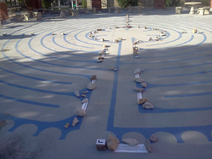
November 15
Hunger and Thirst for the Spirit
Rev. Katrina Palan Interim Regional Minister for the Christian Church in Nebraska and Cotner College Executive Director

Romans 12:2 – “Do not conform to the pattern of this world, but be transformed by the renewing of your mind.” - an exploration into traditions and practices of basic spirituality to find a place of connection with God.

November 22
The Many Faces of Depression
Bonnie Sarton Mierau, CMSW, LIMHP is part of the treatment team at The Attachment and Trauma Center of Nebraska, primarily serving clients whose goals are healing & creating connections and trauma resolution. Bonnie seeks to be a guide as clients move from surviving to thriving.
What is depression? How do we help ourselves and how do we help each other when depression pays a visit? It is Bonnie’s hope to provide tangible and relatable information on depression.

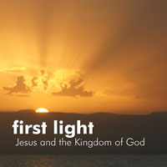
December 6, 13, 20
First Light
Deb Kirwan, member of FirstCentral, will facilitate
Why did Jesus happen when he happened? Why the tiny villages around the Lake? Why the confrontations in Jerusalem? Why then? Why there? Why were the titles of Caesar Augustus — Divine, Son of God, God from God, Lord, Redeemer, Liberator, and Savior of the World — taken from a Roman emperor on the Palatine hill and given to a Jewish peasant on the Palestine plain? What were the priorities of Jesus' proclamation of the Kingdom?
Join us as we explore these questions and others with John Dominic Crossan and Marcus Borg in a DVD-based study of the historical Jesus and the Kingdom of God, on location throughout the Galilee and Jerusalem.

January 10, 2016
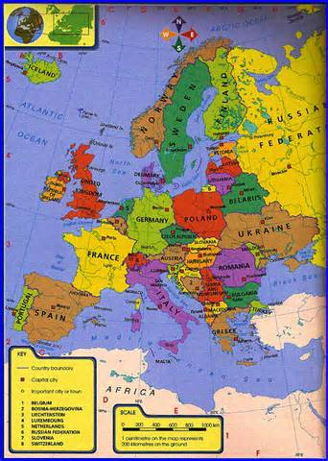
The United States, Greece & the Euro Crisis
Bruce Garver, Professor Emeritus of history, UNO and member of FirstCentral
Bruce will survey the ongoing Euro Crisis with reference not only to Greece but also to the economy and national security of the United States. Even though the Greek economy is smaller than that of each of the fifteen largest American cities, Greece’s political instability and enormous debts to European creditors continue to be of great concern to all members of NATO as well as the governments of all Eurozone countries. Questions from the audience will be discussed.

