FIRST FORUM
Adult Education

Third Floor Parlor 9:15-10:15 A.M.

Child Care available in 1st Floor Nursery

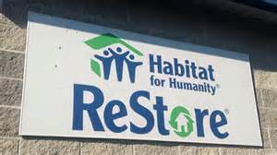
June 5 Habitat for Humanity: more than just building houses – Janneane Gerot, Faith and Special Projects Manager, Habitat for Humanity of Omaha
Learn about all the wonderful things Habitat for Humanity is doing in Omaha.

June 12 Mindfulness Meditation - Jonathan Woodside, the founder of the Mindfulness Outreach Initiative which has been in operation since 2012.
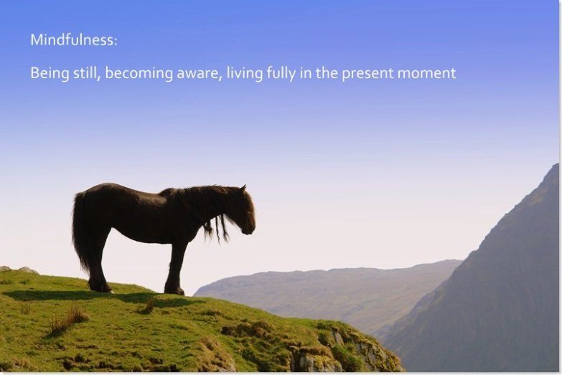

June 19 What is Citizen Advocacy?

Theresa White, Coordinator, Heartland Citizen Advocacy
Heartland Citizen Advocacy is committed to protecting, defending, and promoting, justice to those impacted by mental and physical disabilities. Ordinary people from ordinary communities help support those who need it the most.

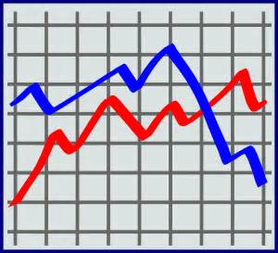
June 26 Trends and Demographics of the United Church
Presentation facilitated by Daryl Malena and Tracy Zaiss, members of First Central
The United Church of Christ is a dynamic, evolving movement of people and institutions across location and time. Scott, Tracy, and Daryl lead an exploration of the 2015 UCC Statistical Profile with an emphasis on how First Central stands in relation to the rest of the denomination's and national trends and demographics.

July 3 – Independence day weekend no forum

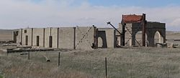
July 10 World War I in Nebraska - Bruce Garver,
Professor Emeritus of history, UNO and member of First Central.
Bruce will discuss some of the experiences of Nebraskans in World War I and in reaction to this war, with some emphasis upon politics, the economy and ethnic groups. He will conclude by discussing the extent to which this war accelerated the advent of women's suffrage, Prohibition, and the acculturation of immigrants.

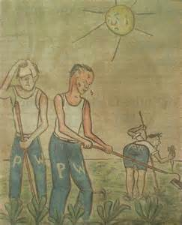
July 17 World War II in Nebraska – Bruce Garver, Professor Emeritus of history, UNO and member of First Central.
Bruce will discuss some experiences of Nebraskans in World War II with some emphasis upon politics, weapons production, and the housing of German and Italian prisoners-of-war. He will conclude by discussing several long-range effects of this war upon the economy and society of Nebraska.

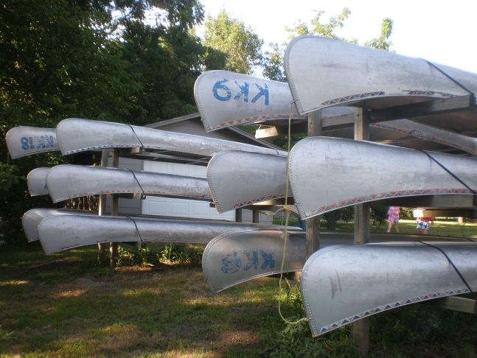
July 24 Tornadoes and Tie Dye: Theology of Summer Camp
Katie Miller, Associate Minister for Student and Family Life at First Central

I'll be talking about my MDiv Constructive Project, which constructed the theology of Kamp Kaleo. Kaleo is a place of story sharing and soul bearing, and an instrumental experience of faith formation for young people in Nebraska. This presentation will examine how that happens.

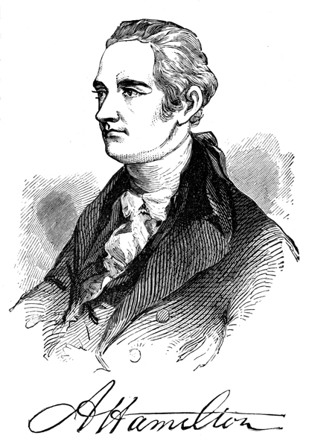
July 31 Alexander Hamilton - Fred Nielsen , Member of First Central and history instructor at UNO
Alexander Hamilton was many things -- a member of the Constitutional Convention, the first Treasury Secretary, the once and future face of the $10 bill, and, we now know, a talented rapper. In many ways, we live in Hamilton's world far more than we do the world envisioned by Washington or Jefferson. Even so, Americans have not held him in quite the same regard as they do the other Founding Fathers. Where is Hamilton's monument? We'll go looking for it, as we explore his life and achievements in both words and music.

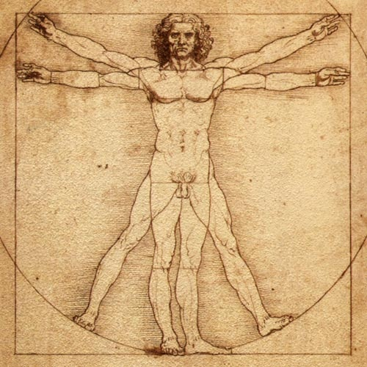
August 7, 14, 21, 28
Philosophical ideas: Understanding Ourselves
Scott Jones, Senior pastor at First Central and lecturer in the philosophy department at Creighton University
Identity, the self, mind-body relationships. Who are we? What are we? Scott returns for a final four week series engaging provocative philosophical questions.

