FIRST FORUM
Adult Education

Third Floor Parlor 9:15-10:15 A.M.

Child Care available in 1st Floor Nursery

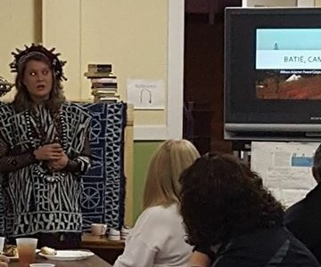
January 3, 2016
Explore Cameroon
People, Culture, Economy
Allison Adams, recently returned Peace Corps volunteer
Allison, from Red Oak, Iowa, shares her Peace Corps experiences in Batie, Cameroon, West Africa

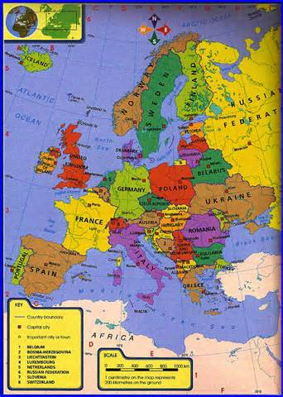
January 10
The United States, Greece & the Euro Crisis
Bruce Garver, Professor Emeritus of history, UNO and member of First Central
Bruce will survey the ongoing Euro Crisis with reference not only to Greece but also to the economy and national security of the United States. Even though the Greek economy is smaller than that of each of the fifteen largest American cities, Greece’s political instability and enormous debts to European creditors continue to be of great concern to all members of NATO as well as the governments of all Eurozone countries. Questions from the audience will be discussed.

January 17
How to Sponsor a Refugee Family in Nebraska
Lacey Studnicka, Program Development Officer for Lutheran Family Services of Nebraska.
Lacey will lead a discussion of the refugee program in Nebraska and what is involved in helping a refugee family. Some will remember when First Central helped two Hmong families about 30 years ago.

January 24
College Planning
Mike Dixon, Admissions Counselor/Assistant Football Coach at Doane College
Mike will discuss what it takes for high school juniors and seniors to get ready for college. Common Application Questions; Student/Athlete Checklist; Academic Scholarships; Doane College Admission process

January 31
Other Views on College Planning
Karen Garver, Marian Fey, and Garret Higginbotham, Members of First Central
The panel will look at college admissions from various points of view. Karen, who worked with returning adult students at UNO, will look at two groups: returning adult students and high school students who want only vocational training. Marian has thoughts about the college and career ready movement in education. Garret will offer insights as a returning student (currently doing doctoral work).

February 7
Confronting our Global Environmental Crisis – Grounds for Optimism

John Schalles, Professor of Biology, Creighton University, and member of First Central

As a professor who teaches ecology and environmental science courses, John understands that confronting the evidence of human-caused damage to natural systems breeds pessimism about the fate of nature and humanity. This forum presents examples of current and possible paths forward to protect and restore the health of natural systems and human society and which provide grounds for optimism.

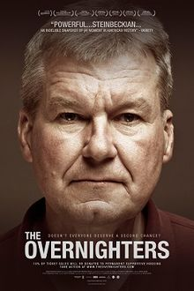
February 14, 21, 28
The Overnighters
Fred Nielsen , Member of First Central and history instructor at UNO
For these three Sundays, we will watch and discuss "The Overnighters," a 2014 documentary about those seeking jobs in the oil fields of North Dakota and the community that wrestles with how to respond to an influx of often desperate people it does not want. Special attention is paid to the minister who insists, often over the wishes of his congregation, that these outsiders must be welcomed. The film combines elements of The Grapes of Wrath and "A Time for Burning," a 1967 documentary on the conflicts within an Omaha church during the peak of the civil rights struggle.

March 6, 13, 20
First Light
Deb Kirwan, member of First Central, will facilitate

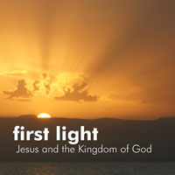
Why did Jesus happen when he happened? Why the tiny villages around the Lake? Why the confrontations in Jerusalem? Why then? Why there? Why were the titles of Caesar Augustus — Divine, Son of God, God from God, Lord, Redeemer, Liberator, and Savior of the World — taken from a Roman emperor on the Palatine hill and given to a Jewish peasant on the Palestine plain? What were the priorities of Jesus' proclamation of the Kingdom?
Join us as we explore these questions and others with John Dominic Crossan and Marcus Borg in a DVD-based study of the historical Jesus and the Kingdom of God, on location throughout the Galilee and Jerusalem.

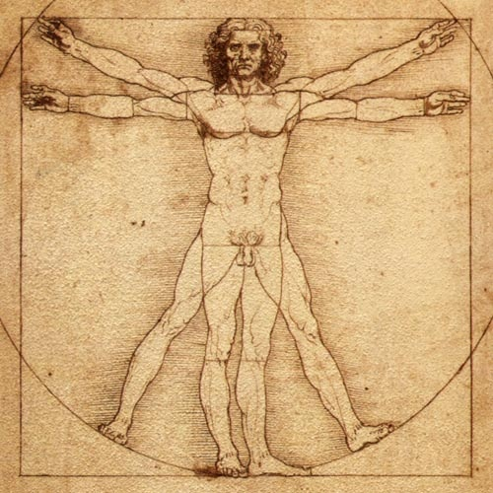
April 3, 10, 17, 24
Philosophical ideas: Understanding Ourselves
Scott Jones, Senior pastor at First Central and lecturer in the philosophy department at Creighton University
Identity, the self, mind-body relationships. Who are we? What are we? Scott returns for a final four week series engaging provocative philosophical questions.

