November 2015 Youth Plans
Friday, October 30 – Haunted House Experience #2 - We’ll meet at 5:30 to bake pizza at church and then go to Mystery Manor. Return to church by 9:00. Let us know by October 29 so we can get the Groupon.

Sunday, November 8 – 11:30-2:00 Ziplining at Mt. Cresent – Meet after church and we’ll head over to Iowa for a fun filled afternoon. Bring a brown bag lunch you can eat in the van. Let us know by November 1 if you plan on attending so we can make reservations.

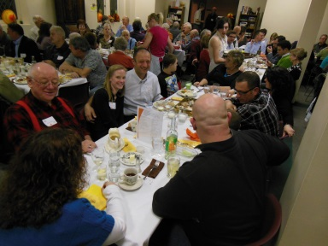
Sunday, November 15 – 12:00-3:00 Horseback Riding – We’ll go as a group after church to enjoy this returning favorite activity! We’ll be grilling out for lunch, wear comfortable clothing that you don’t mind getting a little dirty.

Saturday, November 21 – Serving Turkey Dinner – Youth will eat before they serve Turkey Dinner to friends and family.

Sunday, November 22 – Thanksgiving Interfaith Service at First Methodist – Leave First Central at 3:30. Gather at First Methodist with youth from other denominations and faiths for socializing and practice the youth part of the service. Adults can attend the service which is starts at 5:00. Let us know by November 16 if you plan to attend.

Youth Sunday School – Sundays except for 1st Sundays – 9:45-10:15 AM – 1st Floor Computer Lab - Videos and discussion of challenging topics.

